Business Insight Report

**Abstract**

A blockchain is a distributed network of software that acts as both a digital ledger and a system that enables assets without an intermediary to be transferred securely. On a blockchain network, everything from currencies to land titles to votes can be tokenized, stored, and traded. [1] The technology of blockchain has started a new revolution that has been a new aspect to everyone. This revolution is not very clear to most as to which direction might it direct towards, it can be for the betterment of technology or just a hyped-up version that will not be decentralized. In past years, most of the blockchain's thunder has been stolen by the dazzling tale of cryptocurrency's rise and fall. For others, it was a challenge to differentiate between the underlying blockchain technology and its first client, bitcoin. However, the great crypto crash of 2018 could finally have shaken the grip of bitcoin on the imagination of the people.[2]

**Analysis**

To perform analysis, articles on blockchain revolutions have been considered. Both the articles talk about blockchain technology revolutionizing in a different way. These articles talk in detail about the mechanism, applications, benefits of using, potential threats and challenges on how blockchain might support the common public.

Initially, after calling both the text document articles into the script they were tokenized using unnest_token(), anti_join() and count() functions. By doing so, we can observe that the most repettive words in both the files and obviously the word ‘blockchain’ is the most repeated word in both the articles. Combining both the files into a data frame using the mutate functions would bind the rows and group them based on the authors. This would help us to create a tf-idf function.

After performing Bing sentiment analysis using plotly on the first article, we can figure out from the graph that negatively impacting words dominate over the positive impacting words. Few words like manipulations, threat and hack have been used more frequently than the words like advantages, trust and benefits. Even though the first article talks more about the basics and uses of this new technology, it keeps going back to the problems and challenges that blockchain would ne facing in its initial phases of revolution.

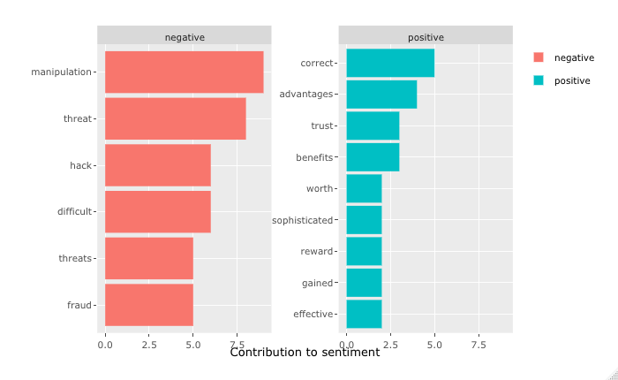

The other article that speaks concentrates more about the tech not being very decentralized is dominating positive words more than the negative words. They talk more about the technology being more powerful and it being a smart innovation rather than focusing on the issues and disruption caused by the tech in the industry.

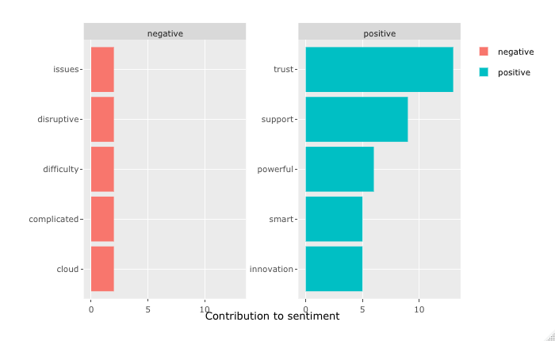

The sentiment analysis using nrc generates a wordcloud that differentiates the words into ten different emotions describing the status of how every sentence in the article was phrased. The first article is more self-centered towards the sentiments as per the analysis. Since, most of the article details about the terminologies of blockchain, its applications in real life and their challenges, the article is very well structured and balanced. Rarely, you can find words that lead to anticipation since blockchain is very new and its technological applications being very limited.

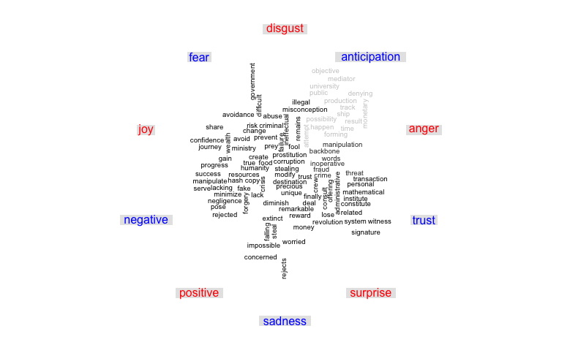

The second article talks in detail about few flaws that causes disruption towards the revolution as its applications being very limited and its uses would not be beneficial to the common public. Here in this article, words with emotions like positive and trust are being used a lot as to which the article is trying to focus on and bring to light.

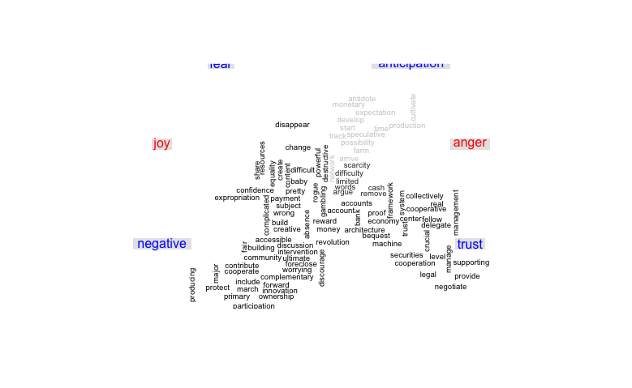

The following bigraph diagram illustrates the words most connected to each other and the most used are showcase the meaning on how the article was structured. Through the bigraph, most of the article speaks about the blockchain technology and its usage of personal information, its working on how the monetary system and the transfer takes place. The differnet ways of government regulating every transaction and the difficulties on stumbling blocks.

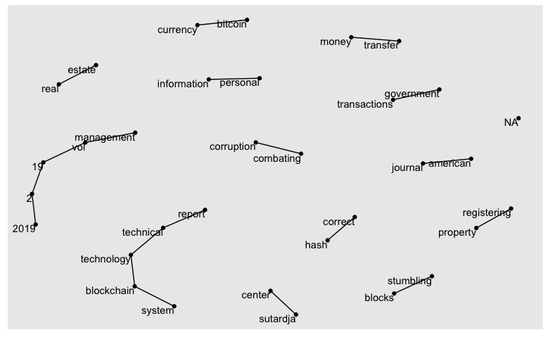

The other article focuses on the difficulties that pull back the revolutionizing technology by using words such as blockchain based technologies and how its distributed ledger forms affect the new start-ups if at all they are planning on bringing the new technology.

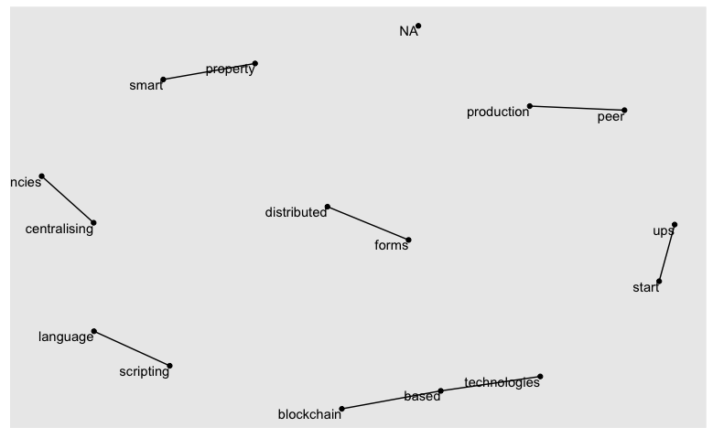

**Recommendations**

Blockchain would have a tremendous impact on deferential levels, it will alter the way all individuals adopt to negotiate with conventional intermediary parties over decades and challenge them, on the other hand it faces several barriers that stumble blocks to be completely run-in diverse sectors.

Although the first article focuses on most of the applications and possibilities of its growth into a new era. Transactions in blockchain is not mostly preferred by most of the people. Only the tech-savvy people are into its applications currently and with the concept being so simple and diverse, it should be accessible to the common public. That is when the revolution has reached its saturation state in the market. And as the tech leaders have stated, it is still a far way to be fully revolutionized.

1. Blockchain Research Institute. (2021). Retrieved 11 February 2021, from https://www.blockchainresearchinstitute.org/an-intro-to-blockchain/#:~:text=A%20blockchain%20is%20a%20distributed,of%20assets%20without%20an%20intermediary.&text=Anything%20from%20currencies%20to%20land,exchanged%20on%20a%20blockchain%20network.
2. The State of the Blockchain Revolution. (2021). Retrieved 11 February 2021, from <https://knowledge.insead.edu/blog/insead-blog/the-state-of-the-blockchain-revolution-11876>